Managing Fatigue & Overstimulation After Brain Injury

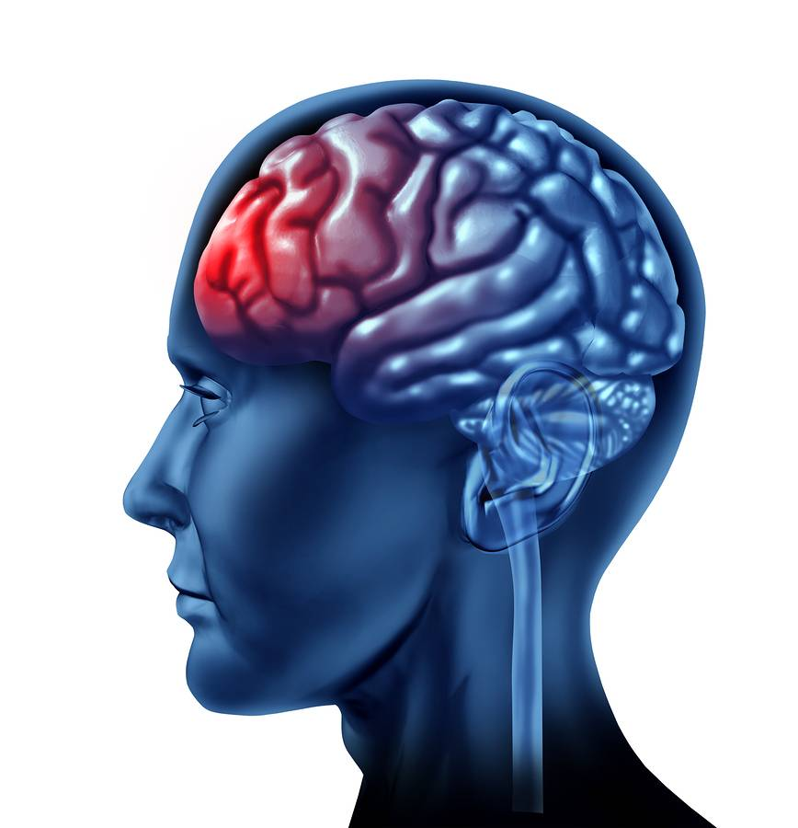

Fatigue After a Brain Injury

Fatigue is a personal experience that is different for everyone. For some it may feel like overwhelming tiredness, which makes them unable to complete normal activities of daily living. People may say they feel exhausted, lacking in energy, weak, unable to motivate themselves, or
sleepy. For others it may worsen difficulties associated with their injury, for example, forgetfulness, irritability, slurred speech, distractibility or dizziness.

Fatigue often makes resuming previous roles and daily activities more difficult and can contribute to people becoming socially isolated.

Therefore, fatigue may affect:
- What we think (for example, “I shouldn’t feel like this, I’m useless”)
- How we feel (for example, frustrated, unable to cope, irritable)
- What we do (for example, avoiding activities, or increasing effort).

Many people experience fatigue following brain injury, but the underlying causes are still poorly understood. Fatigue may be a result of direct damage to brain structures or due to other
factors such as needing to make more effort to think or move.

Methods of Managing Fatigue

Nutrition and Hydration
Some types of food can make us feel more ‘sluggish’ and lacking in energy, while others can help to maintain energy levels for longer periods. Thinking about eating the right things at the right times, according to what you are doing, is important in managing fatigue.

Fast-releasing carbohydrates, in foods such as sweets, sugary cereals, white bread and sugary drinks, break down quickly and flood the blood with too much sugar. Surges in blood sugar levels may result in a short term increase in energy, followed by decreased energy and concentration.

Slow-releasing carbohydrates, in foods like brown rice, wholegrain pasta, fruit and vegetables, are more ‘complex’ and contain fiber that helps to slow down the release of sugar and so maintain energy levels. It is important for the diet to have a balance of ‘complex’ carbohydrates and protein from foods such as meat, fish, dairy products and nuts.

Drinking enough fluid, particularly water, keeps the brain and body hydrated. This is important to help the brain and body to work effectively. Drinking lots of caffeine, such as in tea, coffee and some fizzy drinks, may increase your alertness initially, but this is often short-lived.

Environmental Modification
To make best use of your available mental and physical abilities you may want to think about the environment in which you live and work. Being organized and avoiding distraction can help to minimize the physical and mental effort that is required to complete an activity.

Suggestions:
- Energy conservation’ techniques will be helpful if you experience ‘physical fatigue’; for example, sliding instead of lifting items, using a laundry basket on wheels or having items used regularly within easy reach.
- Organize your workspace, such as your kitchen or office area, keeping it as uncluttered as possible. Keep things in the same place so that you don’t waste energy searching. Try to have ‘a place for everything and everything in its place (i.e. a “home” for your wallet, keys, etc.)
- Use good lighting in order to prevent eye strain. If able, wear “blue blocking” glasses if in front of a computer or tablet screen for prolonged periods.
- Use labels/signs to help you to find things more easily.
- Think about turning off the TV or music when you are trying to concentrate on a task.
- Prevent interruptions from other people – put a ‘Do Not Disturb’ sign on the door.

Pacing
Pacing is a way of balancing activities that you do throughout the week. By spreading tasks out you may be able to reduce fatigue.

Pacing includes:
- Having regular rest breaks
- Planning your time and being organized
- Prioritizing where to use your energy
- Knowing what your triggers are and working within your available resources.

It is important to plan when to take rest breaks during the day. Resting requires going somewhere quiet and sitting or lying down for a short period. It is better to take breaks often rather than having one long break when fatigue hits you. Engaging in relaxation can help to cope with stress and can promote long-
term health by slowing down the body and quieting the mind.

Relaxation can also help improve energy levels, leaving you feeling refreshed and making you feel more mentally alert, thus making the most of your resources. People with fatigue are advised to take regular breaks; however, many people find it hard to do nothing. Relaxation techniques can give a helpful focus and maximize the benefit of your rest periods.

While pacing yourself is vital when doing less desirable activities (like mowing the lawn), an even more important factor with management of fatigue after brain injury is to prioritize activities and engaging in behaviors that matter the most to us. The following excerpt is fun way to think about this process…

A professor stood before his philosophy class and had some items in front of him. When the class began, he picked up a very large and empty jar and proceeded to fill it with large rocks. He then asked the students if the jar was full. They agreed that it was. So the professor then picked up a box of pebbles and poured them into the jar. He shook the jar lightly. The pebbles rolled into the open areas between the large rocks. He then asked the students again if the jar was full. They agreed it was.

The professor next picked up a box of sand and poured it into the jar. Of course, the sand filled up everything else. He asked once more if the jar was full. The students responded with a unanimous "yes." The professor then produced 2 cups of water from under the table and poured the entire contents into the jar, effectively filling the empty space between the sand.

The students laughed.

“Now," said the professor, as the laughter subsided, "I want you to recognize that this jar represents your life. The large rocks are the important things--your family, your children, your health, your friends, and your favorite passions--things that if everything else was lost and only they remained, your life would still be full. The pebbles are the other things that matter like your job, your house, your car. The sand is everything else--the small stuff.”

“If you put the sand into the jar first," he continued, "there is no room for the pebbles or the large rocks. The same goes for life. If you spend all your time and energy on the small stuff, you will never have room for the things that are important to you. Pay attention to the things that are critical to your happiness. Take care of the large rocks first, the things that really matter. Set your priorities. The rest is just sand and water."

We frequently under-prioritize health and self-care. But, if we take care of ourselves, we will have more energy for other areas of our lives. Our health should be our biggest “rock.”

Pacing in Practice

1. Activity

One thing at a time
When you are doing a specific task, such as preparing a meal, it’s very tempting to try to complete it in one burst of activity. Instead, split the activity into a series of small stages, with periods of rest and relaxation in between. Only attempt one activity at a time.

Energy use
Activity incorporates anything that uses energy, whether it is a physical, mental or emotional demand.
As well as being able to class activity as physical, mental or emotional, you can also rate an activity according to how much energy it uses.
Activities will be low, medium or high consumers of energy. You need to consider this when you are planning your day. An activity diary may help

Be energy wise
Look at whether there is anything you can do to make an activity easier and less taxing. For example, if you are washing up, can you sit rather than stand? Try soaking dishes first so that they are easier to clean, then leave them to dry on the draining board. In this way you might be able to modify a high-energy activity into a medium-energy activity.

It’s particularly important to take this approach with demanding activities that may be taxing in a number of different ways. For example, shopping will include travelling, sitting, walking, carrying, and coping with a busy environment with bright lights and noise.

Don’t just do things the way you have always done them. Only stick to old routines if they are manageable. For example, if you get up in the morning and have breakfast, build in a rest before you get dressed. Activities that you may have previously carried out automatically, such as showering, drying your hair etc. now need to be included in your plan.

It can help to think of your available energy as being like money in a bank account. You have a certain amount to spend, and when you exceed that you go into debt. To manage your money wisely you have to budget your spending and aim to stop spending that you can’t afford. Economizing will help your budget to go further.

Review your priorities
Look at each activity and judge how essential it is. You may need to adjust your usual thinking, as you won’t be able to do everything that you did before you became ill. Can you put off the activity to a later date? Can you ask friends or family to help you? Perhaps you can drop it altogether? This can free up time and energy, allowing you to choose an activity that you really enjoy. When you are ill and your activities are limited, it’s very easy for the boring things in life to take over. You may feel guilty if you let them go, or you might think that’s where your focus should lie. In fact, it’s very important for your well-being that you allow yourself time for enjoyable activities, so make sure you have a balanced mix of those that you have to do, and those that you want to do. Don’t feel guilty!

Balance
Balance is the key not only in the activities that you choose, but also their type. Your day should include a balanced mix of physical and mental activity and you should deliberately alternate or ‘switch’ between the two.

2. Rest and relaxation

Good quality rest and relaxation is an essential part of a successful pacing program and you need to build this into your day. The amount of rest that is needed varies from person to person. Some people need a lot of rest while others find that if they are getting good quality rest they can cope with frequent but short ‘mini-rests,’ perhaps lasting as little as five to ten minutes.

Relaxation is about achieving complete rest of the body and mind. If you feel that your brain or body is being stimulated, you are not achieving true relaxation. It can take some time to learn to ‘switch off’ both physically and mentally. Some people find it very difficult to relax properly and feel guilty if they’re not busy or doing something ‘useful.’

There are several techniques or skills that you can learn to help achieve a state of relaxation. It helps to: make room for relaxation, learn good breathing, tackle tension and unwind.

Make room for relaxation
Set aside a time and place to relax. You don’t need to go to bed to relax and in fact it can be best to save your bed for night time sleep. Where you choose will depend on your home circumstances but you need to find a place where you won’t be disturbed. Switch off the phone and let those around you know that you don’t want to be interrupted. Get yourself really comfortable, either lying down on a mat, or sitting in a chair with your neck, feet and arms well supported. Make sure you are warm enough.

Good breathing
Learning techniques for good breathing, and remembering to put them into practice, is important. When you are feeling stressed, anxious or worried, your breathing can be shallow and quick. This is called hyperventilation. When you hyperventilate you use only the upper part of your chest, whereas good breathing uses your whole chest and lung area. A lot of people are unaware that they are hyperventilating and it can become a habit. It alters the blood chemistry and causes symptoms such as pins and needles, dizziness, palpitations, breathlessness and chest pain, and heightens anxiety and panic. Naturally these symptoms can cause further worry and anxiety and a vicious circle is created.

Become aware of your breathing
Place one hand on the top of your chest and the other hand at the bottom of your rib cage/abdominal area. Breathe in slowly through your nose and into the ‘bottom’ of your lungs. You should feel your abdominal area rise while your chest should only move slightly.

Abdominal breathing involves two basic components:

        - Breathing control
        - Find a quiet, comfortable spot where you won't be disturbed.
        - Sit in a comfortable chair, or lie down if breathing from the diaphragm is difficult for you.
        - Breathe slowly, from the diaphragm (belly breathing).
        - Breathe in a smooth continuous motion. Do not hold your breath prior to exhaling. Allow your breath in to be smoothly followed by your breath out. If you become dizzy or feel faint, just stop for a little while and then try again.

        - Concentration
  - Imagine your breath as a full circle (see below). Imagine your breath in and out to be a smooth, circular process without becoming stuck or jagged (holding patterns).
  - Repeat the following in your mind. Inhale: “In full body.” Exhale: “Out letting go.”
  - If you notice yourself becoming distracted, gently bring your attention back to your breathing. Allow the distracting thought to pass away.
  - Once you start to feel comfortable with counting, you can start to slow the number of breaths you take.

Out Breath
In Breath

Trauma breathing pattern (jagged holding pattern)

Relaxed Circle breathing pattern

When you take a breath in, pause for a moment and then breathe out slowly either through your nose or mouth. Make sure you breathe out fully. Repeat these steps slowly 10 times. You might need to build up to this number. It’s a good idea to practice breathing like this on a regular basis.

Tackle tension
There are a number of different techniques to help tackle tension so you will need to find out what works best for you. Some people find that focusing on a pleasant or relaxing image can help to calm the mind and body. Another method is to consciously relax tension in your muscles. Your aim is to recognize when your muscles are tense, then to relax them in response to this. One way of doing this is to clench a fist for a few moments and then unclench. Note how tense and uncomfortable it felt when clenched and how good it feels when fully relaxed. Try this with other muscles in the body, for example your neck, shoulders, and back. Focus on whichever area you think might be tense. Clench for a few moments and then unclench. Some people find it helpful to systematically work their way around the body from head to toe. As you get better at the technique, it’s possible to bypass the clenching and just ‘let go’ of each muscle group in turn. This can also be used alongside deep, slow breathing as a ‘first aid’ measure in stressful situations.

3. Finding a sustainable baseline and stabilizing activity

To find the amount of activity that you can confidently manage on a day to day basis, you first need to have a good awareness of your current activity patterns and their impact on your symptoms and how you feel. How do your symptoms change and fluctuate in relation to what you have been doing? Remember to consider not just physical activity but also mental and emotional activities.

Keep a diary
It can help to keep a simple diary of activity and rest. A diary will help you to understand what is going on and enable you to reflect on your own particular circumstances. The effects of ‘overdoing it’ may not show up for a day or two but your diary may help you to identify what triggered your symptoms.

Sometimes, diaries are more helpful to identify peaks and troughs in activity, than symptom responses, because of the delay. Also, of course, symptoms vary for other reasons than activity levels. You will need to keep your diary until you are able to spot patterns or apply the pacing and planning principles in your head, or build them into your routines. A diary may need to be temporarily restarted during a setback or relapse and can also be helpful when attempting to start a significant activity change, for example returning to work or study, or starting to drive a car again.

Calculate your baseline
There are several ways to work out the length of time you can do a particular activity, and you may need to experiment to find the best one to suit your situation. This can take some time. You will need to work out a baseline for each different activity you undertake.

Techniques include:
- The 75% rule. If you think that you can carry out an activity for 20 minutes, try reducing your activity time by five minutes to 15 minutes (75% of 20 minutes). The aim would then be to maintain 15-minute blocks of activity interspersed with rest/relaxation periods throughout the day.

- An even simpler way is to set your baseline at about 50% of what you think
- you can do on an average day.

- Split each activity up with 5-10 minute rest breaks.

When you’re setting a baseline, the golden rule is to remember that all activities must be set at a level that can be maintained on both a good and a bad day. It can be very disappointing to find that your baseline is lower than you expected but remember that you are taking a step back in order to go forward!

Stabilizing your activity
When you have set your baseline you need to give your body time to settle into the level. How long this takes will vary from person to person but it can take weeks. You will be ready to gradually increase your activities when you feel your body has acclimatized to the level and you can confidently sustain it.

4. ‘Increasing as able’

As natural recovery occurs following a brain injury, and you have found a sustainable baseline, you should find that you are able to gradually increase your activity. You could do this by adding one small extra task or by lengthening an existing activity. Any increases should be very gradual and the process should be initiated and controlled by you.

If you decide to extend an activity, do this by 10% and no more. For example, if you can currently carry out housework for 10 minutes, try increasing it to 11 minutes. Or you could break this up into two five and a half minute activity periods with a rest/relaxation period in between. Increasing from 5 to 10 minutes would not be advisable as this is a 100% increase! Remember: only increase by 10%. Over time, repeat this process so that your activity periods are gradually lengthened and your rest periods shortened. Whichever approach you choose, do not be too ambitious and only increase activities little by little.

Side effects and listening to your body
Learning to pick up on the signals that your body gives you and making sense of them is an important part of pacing. You will need to learn to distinguish between the normal effects of increasing activities and the negative effects of having over-done it. For example, you are likely to notice a temporary increase in stiffness or fatigue when increasing your activity levels. This is normal and your body will need a few days to adjust and adapt. Stretching after exercise can help to reduce muscle soreness. However, if your fatigue and other symptoms continue for a week or longer this might indicate that you have increased the activity too quickly.
The signals that your body gives out can be quite subtle and are not necessarily physical, such as pain or fatigue. Feeling irritated, stressed or starting to lose concentration can equally be an indication that you are doing too much. Some people benefit from learning to recognize these early warning signs – but for others, these signs are post-exertional. In other words, they only happen sometime after they have already overdone things.

Goal setting
To help you increase your activities, set targets against which you can measure your progress. These goals must be realistic, achievable and sustainable. For example, if concentration and memory problems make reading difficult, you might set yourself a specific reading goal. Choose a book that is enjoyable and not too taxing, then build in small stages – tackle a couple of pages at a time, or a chapter, and build in quality rest periods. Similarly, you could choose a newspaper or magazine.

If you want to build up a physical activity, such as walking to the shops, consider your current capacity or baseline and then set yourself a realistic and measurable goal. If your baseline is currently set at walking regularly around your home, build in several small stages before the end goal of getting to your local shop. Your first stage may be to walk outside to the garden or to the pavement. You might then have several stopping points along the way. Don’t be tempted to make big jumps or increases, however well you may be feeling. In the end, a slow and steady approach will help you to reach your goals more quickly.

5. Stumbling blocks
Now that you understand how pacing works, you can probably imagine how hard it can be to put into practice. There is likely to be pressure from everyday life and from yourself or others to deviate from your plans. If your lifestyle makes pacing extra difficult you will need to take some time to stand back and reflect. Think about whether everything you are attempting to do is essential.

Taking on too much
It can be hard to let go of things that might be preventing you from pacing effectively. There are likely to be demands and pressures from other people and you may also be battling with your own expectations. If you have standards that are getting in the way of pacing you will need to adapt and change them.

It’s all too easy to push yourself to finish a task you have started, or to feel bad about ‘letting somebody down.’ It’s important to learn to let go and to make fewer demands on yourself. It just isn’t possible to do all the things you did before your brain injury. You may have people in your life who drain you emotionally, or you may be the sort of person who is always available in a crisis. Do you always put other people first, regardless of how you are feeling? Remember that emotions are far harder to account for when learning to pace.

The unexpected
Life is unpredictable, so however thoroughly you might plan your time you can still be caught out by the unexpected. Because of this it’s important not to work right up to the margins of what you can sustain – leave a bit of a gap or cushion so that you can deal with any activities that come out of the blue. If you are caught out, you will need to compensate by removing a similar activity from your plan.

Setbacks
Setbacks or relapses can happen for all sorts of reasons but often they are caused by trying to do too much. If you think you may be heading for a setback, take some time to review why this is happening. It’s sensible to drop back to a really secure level of activity while you recover, even if this means dropping several levels, or going back to where you started, before building up again. It’s not a good idea to cut activity out altogether because too much rest and too little activity can exacerbate the setback rather than improve matters.

Dropping to a lower activity level can be demoralizing, but the good news is that people usually find it’s easier to build up through the levels after the first time. If you are having regular setbacks/relapses it’s likely that you are attempting to do too much when you are going through a good phase, then suffering payback.
Think about the following:
- Did I set my baseline correctly?
- Have I attempted to increase my activity too quickly?
- Have I been pushing myself too hard?
- Have I taken into account all my activities – emotional as well as physical and mental? Am I resting properly?
- Am I getting enough good quality sleep? Or sleeping too much?
- Are my goals realistic?

If you are finding it difficult to return to normal activity levels after a setback, it’s advisable to talk to your doctor or other health professionals involved in your care. Learn from your experiences. Develop a personal strategy for preventing the same thing from happening again.

Pacing Log

Estimate how long you can safely do one of your regular activities (i.e., walking; dishes) without becoming overly exhausting, and then mark 75% of that effort as your “active” goal. For example, if you feel you can manage 30 minutes of standing in the kitchen while cleaning up dishes without any trouble, then your “active” goal would be about 22 minutes. Then incorporate a 5-15 minute break and if the project is not finished but you feel you can continue, repeat the same cycle.

Once you have established a baseline but feel you are ready to build and extend an activity, do this by 10% and no more. For example, for your 22 minute cleaning chore, increase it by only 2 minutes. Over time, repeat this process so that your activity periods are gradually lengthened and your rest periods shortened. Whichever approach you choose, do not be too ambitious and only increase activities little by little.

Use the table below to record how you pace activities this week (more are also included in the back). Use the sample as your guide, where each period of activity and rest equals one cycle. In the example provided, the markings of 22 / 10 (1) indicating working for 22 minutes and resting for 10 minutes for one cycle of pacing. On the last column, mark your level of fatigue on a 1-10 scale (1 minimal fatigue and 10 exhausted) to help you track when you may be overdoing it or prepared to increase your baseline.

Sample Log

 | Sample | Activity 1 | Activity 2 | Activity 3 | Fatigue
Activity | Cleaning Kitchen
Active Goal | 22 minutes
Rest Goal | 10 minutes
Day 1 | 22 / 10 (1)
Day 2 | 22 / 10 (2)
Day 3 | 22 / 10 (3)
Day 4 | 22 / 10 (2)
Day 5 | 22 / 10 (3)
Day 6 | 22 / 10 (2)
Day 7 | 22 / 10 (2)

Extra Sheet 1

 | Activity 1 | Activity 2 | Activity 3 | Activity 4 | Fatigue
Activity
Active Goal
Rest Goal
Day 1
Day 2
Day 3
Day 4
Day 5
Day 6
Day 7

Extra Sheet 2

 | Activity 1 | Activity 2 | Activity 3 | Activity 4 | Fatigue
Activity
Active Goal
Rest Goal
Day 1
Day 2
Day 3
Day 4
Day 5
Day 6
Day 7

Extra Sheet 3

 | Activity 1 | Activity 2 | Activity 3 | Activity 4 | Fatigue
Activity
Active Goal
Rest Goal
Day 1
Day 2
Day 3
Day 4
Day 5
Day 6
Day 7

